**Database as a Service**

Our project is to evaluate various cloud based databases and use the database which outperforms others. The database chosen will be used in our application to determine the universities based on various factors and that will help students to figure which universities are better. In order to do this we are created some set of APIs which provides the data pertaining to universities. User can edit and reuse our APIs and hence we offer ‘**API as a Service**’ as well.

Our project can be distinguished into following categories,

1. **Data Source and massaging :** We collected the data from National Center for Education Statistics (NCES) website. Our dataset consisted of enrollment from universities in Missouri state. The data was collected over 14 years for the following university : Park University, UMKC, Missouri state university, Rockhurst university and University of Central Missouri. Also, the dataset when downloaded was obtained in an excel sheet format. We implemented a java script to automate the process of uploading the data into the cloud.

Data which is obtained from the NCES website contains data which is not relevant with the scope of this project. So we are massaging the data and storing only the required fileds into the database.

1. **Databases (description and the discussion of gist of result observed)**

We are using the following two databases in the project for comparison:

* MongoLab
* Cloudant

Following observations were made during the completion of the project,

1. When the data is store in the cloud databases, ‘MongoLab’ has the less response time and slightly more throughput than the ‘Cloudant’ cloud database.
2. When the data is retrieved from the cloud databases, ‘MongoLab’ has the less response time and slightly more throughput than the ‘Cloudant’ cloud database.
3. ‘Cloudant’ cloud database is more available than ‘Mongolab’ cloud database
4. ‘Cloudant’ cloud database is easy to replicate than the ‘MongoLab’ cloud database.

Since MongoLab cloud database has more response time than Cloudant we decided to use the MongoLab cloud database in our project.

1. **REST APIs (server code and how to use and create a new API)**

This is the part of our server code. Using the REST APIs users can both upload the data on the server and retrieve the data (pertaining to universities) from the server. These APIs are nothing but the Java annotation classes. Depending upon the HTTP method (GET, POST, PUT or DELETE), the APIs are called and perform the activities which they are developed for,

**Base API Url**: http://dbaas.mybluemix.net/api/total/{university_name}/{year}

Below is the java code snippet

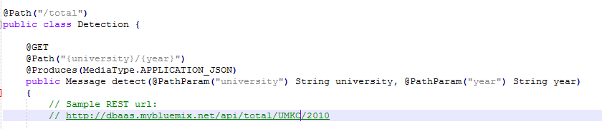

**How to create a new API?**

New api will be created on top of the base API URL. For example if we want to determine the how many students got admission in fall or spring semester we can use an extra parameter in the API call, eg: http://dbaas.mybluemix.net/api/total/{university_name}/{year}/**{semester}**

**Server side Code and be manipulated something like as follows:**

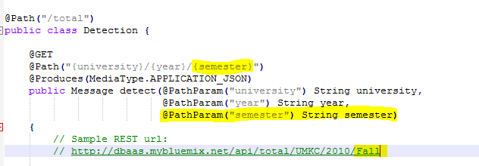

Once we have this additional parameter we can use it whatever way we like.

1. **Data Type**

Currently we are returning ‘JSON’ data to the client side. User can modify it to ‘XML’, ‘ATOM’ etc by modifying the following parameter at the server side,

**@Produces(MediaType.APPLICATION_{DATA_TYPE})**

where in DATA_TYPE can be ‘XML’ or ‘ATOM’ or whatever data type we want to return to the client.

1. **Visualizations**

We have also supplied some sample client code which represents the analysis of the data return from the server.

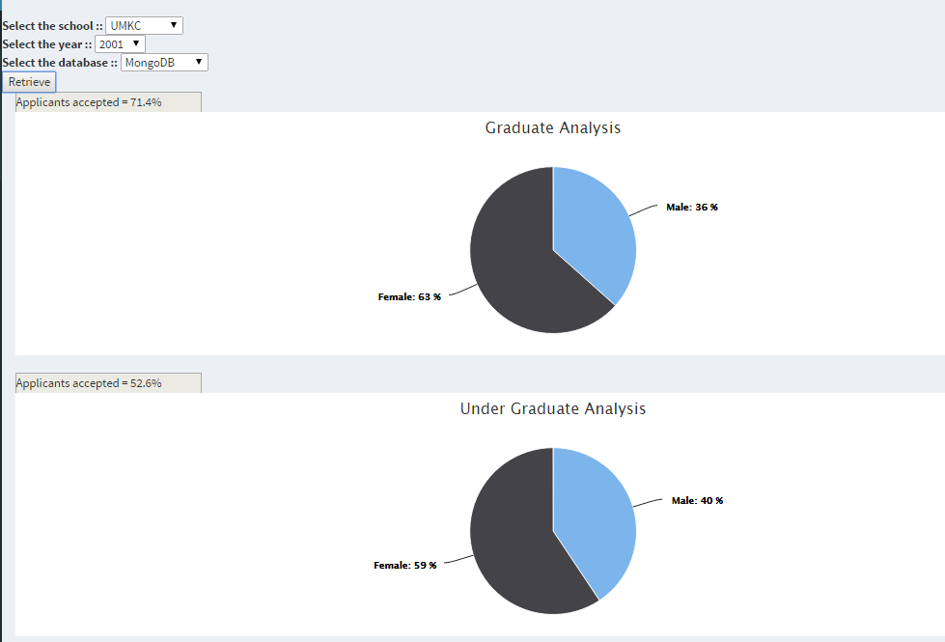

Many more visual representations can be coded at the client side using javascript and css.